Canestrari: Rumors of my retirement are rumors
by Jimmy Vielkind, Capitol bureau in Ron Canestrari

Posted on February 16, 2012 at 10:20 am
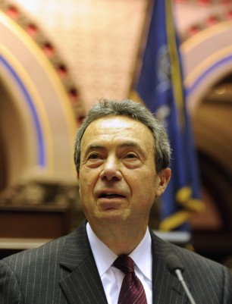
I’ve heard now from two political sources in Albany County that Assembly Majority Leader Ron Canestrari, D-Cohoes, was contemplating retirement at the end of his term this year.

That’s not the case, he told me flatly. He has not discussed retirement plans with anyone and plans to seek re-election.

“I’m hearing the rumor a lot too, I don’t know where it started, except people who want to run for office. I expect to run, yes I do,” he said. “A lot of this happens during a redistricting year when they think changes are being made, and it can be a time for members to leave. Certainly I have a lot of time in and am eligible to take my retirement, but I don’t do it. So that’s a consideration on my part, and a lot of this stuff goes on.”

AD-106

